
Session 1 - Work Education 2nd Feb 26
Multiple
Years 7 - 12
Duration: 40- 50 minutes

Multiple Intelligence Quiz
Summary
Students learn about the different types of intelligences and their own individual strengths.
They complete a Multiple Intelligences Quiz and consider how these concepts impact their future job and career choices.

Learning Intentions
Explore the characteristics of individual multiple intelligences and strengths Understand how the ‘smarts’ relate to various jobs

Student Success Criteria
I can identify my multiple intelligences and strengths
I can determine how my intelligences match to different jobs

- Direct students to the school careers website. Students are encouraged to familiarise themselves with website – especially career targets. (No Need to login to explore website)

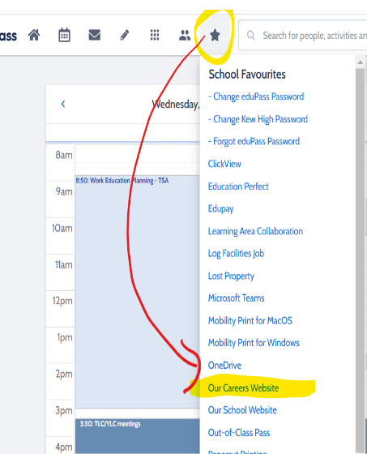

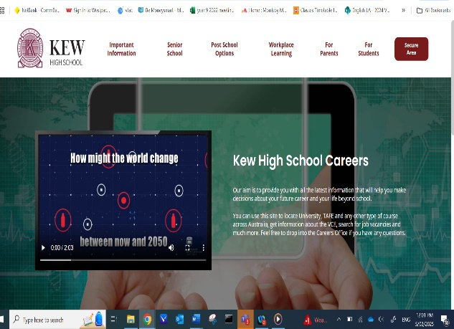

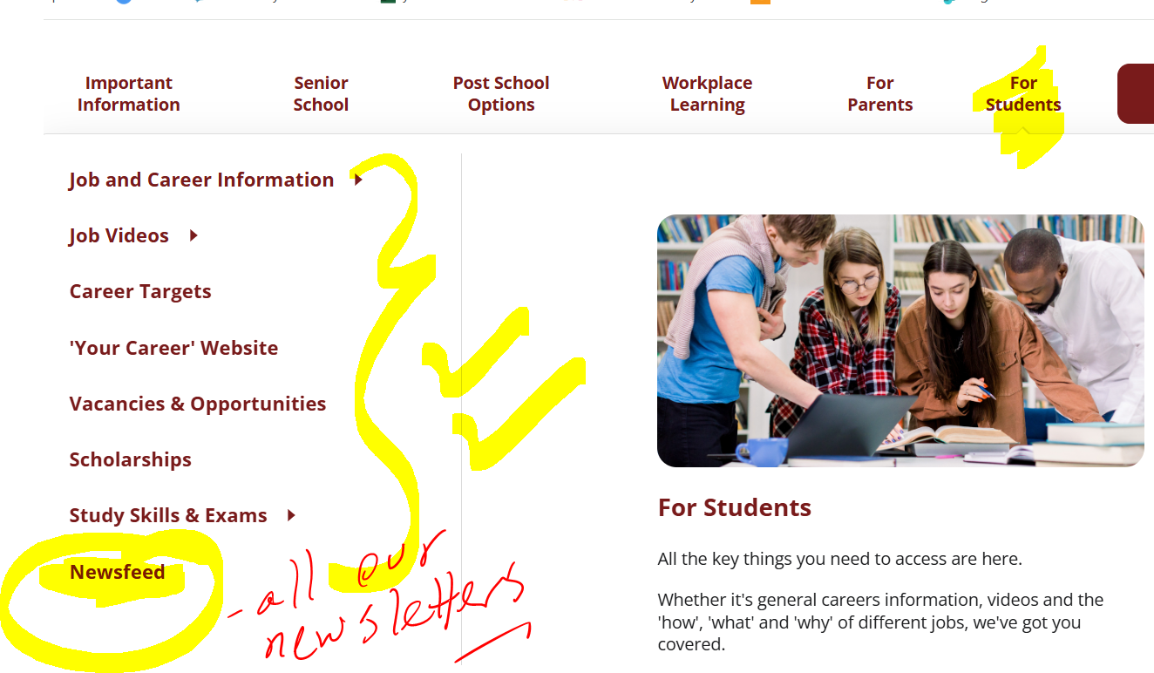

- Students to use the dropbox, (Career Targets) to further explore areas of interest – by clicking on any occupation, they will receive further information

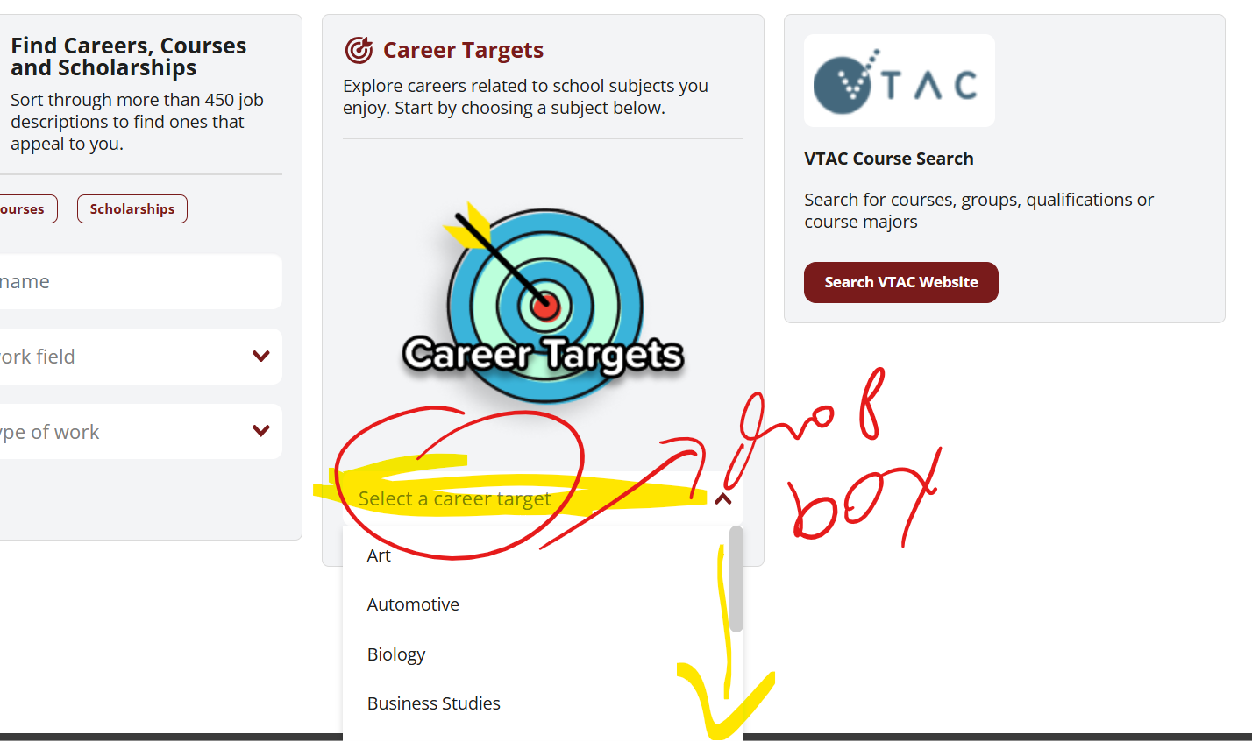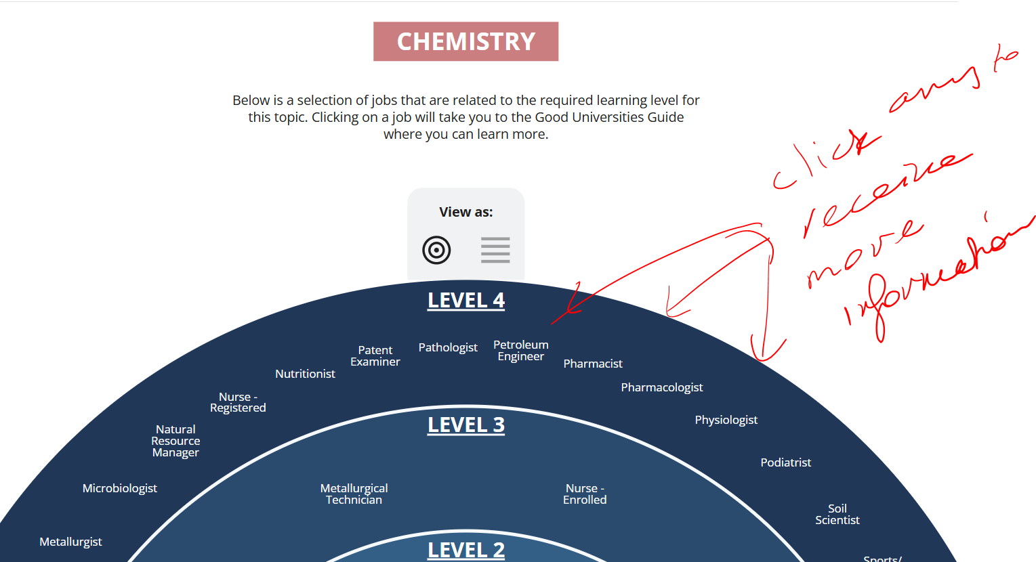

- Students to login to the student area in order to access tasks. See link below for new students (‘how to login/create an account instructions’)

Career Tools how to create an account.pdf

- Select ‘Learning About Myself’ and open the ‘Multiple Intelligences’

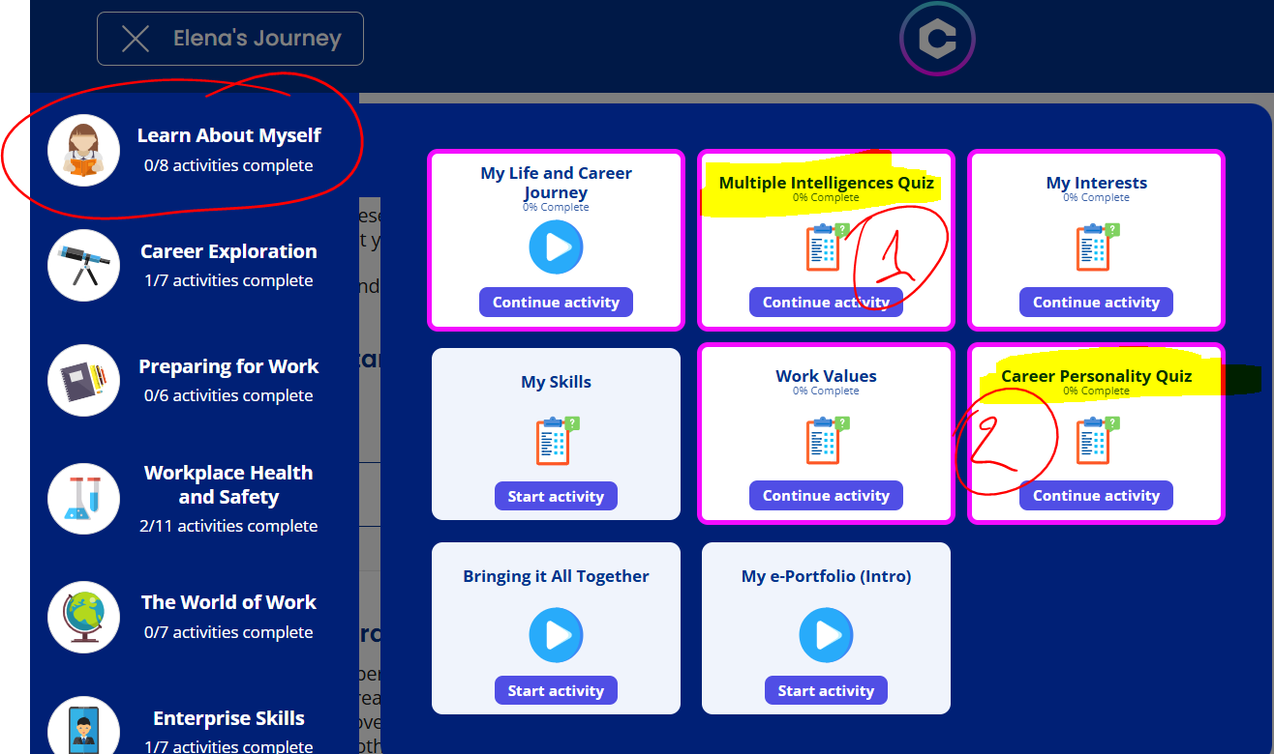

- Students complete Quiz
- They rate each statement from 1-5. There are 64 statements designed to match into the 8 multiple intelligences. (They are – music smart, body smart, people smart, self smart, picture smart, word smart, logic smart or nature smart)
- Information is revealed to them
- Students can then watch videos further explaining this information and complete questions.

Questions:
- Three strongest intelligences
- Do you agree/disagree with results? Describe why
- List top three strengths from strongest intelligences
- Students select three jobs (either from their list in the report or any other they may be interested in) and a description on how the job relates to their strongest intelligence

If time permits students can continue with Career Personality Quiz (found in the same section)


